OPEN ENDED LAB REPORT
DOT PRODUCT USING POSIX THREADS (PTHREADS)
Objective
The purpose of this lab is to learn how to use the POSIX threads (Pthreads) library in C to perform parallel computation.
We begin with a simple sequential dot product program and then convert it into a multi-threaded version using mutex locks to ensure data consistency.
Provided Serial Program: dotprod_serial.c
Description
This program calculates the dot product of two vectors a and b of length 1,000,000, where each element equals 1.0.
It runs sequentially (using a single thread) and reports the total sum and execution time.
Source Code: dotprod_serial.c
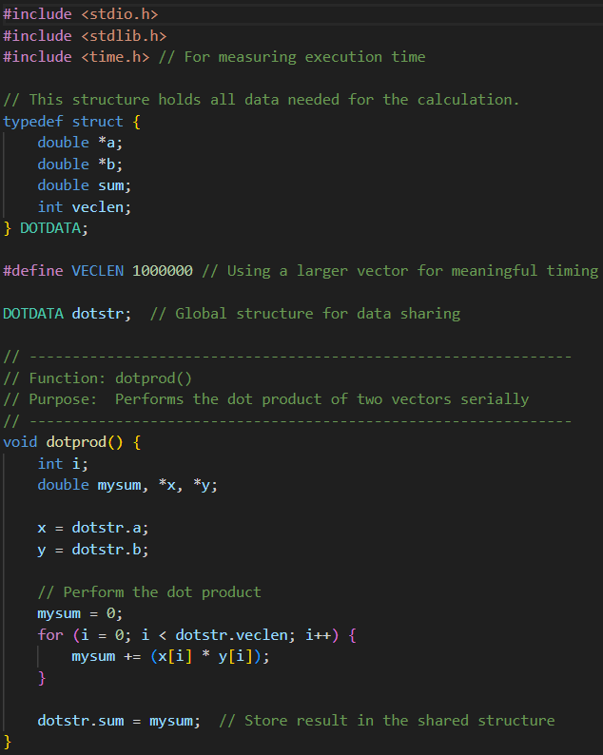
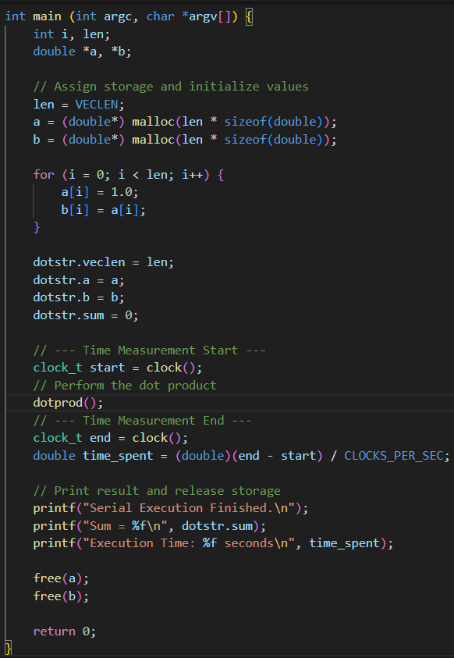
Output:
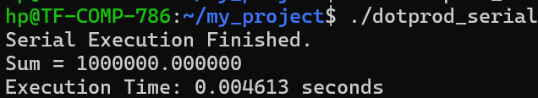
Task 1 – Discussion Question
Why is the serial program free of race conditions?
In the serial version, only one thread (the main thread) performs all the operations sequentially.
It alone accesses and modifies the variable dotstr.sum, so there is no competition for shared data.
Because no two parts of the program run at the same time, there is no chance of interference or inconsistent data updates.
Therefore, the program is inherently free from race conditions and does not need synchronization mechanisms like mutexes.

Task 2 – Multi-threaded Version: dotprod_mutex.c
Description
In this version, the computation is split among four threads, where each thread handles one-quarter of the total vector.
Each thread computes its partial sum, and then safely adds it to the global total sum using a mutex lock to prevent race conditions.
Source Code: dotprod_mutex.c
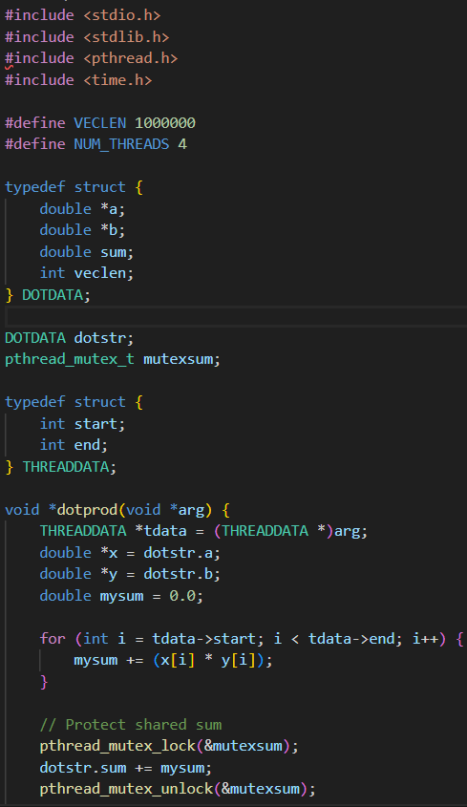
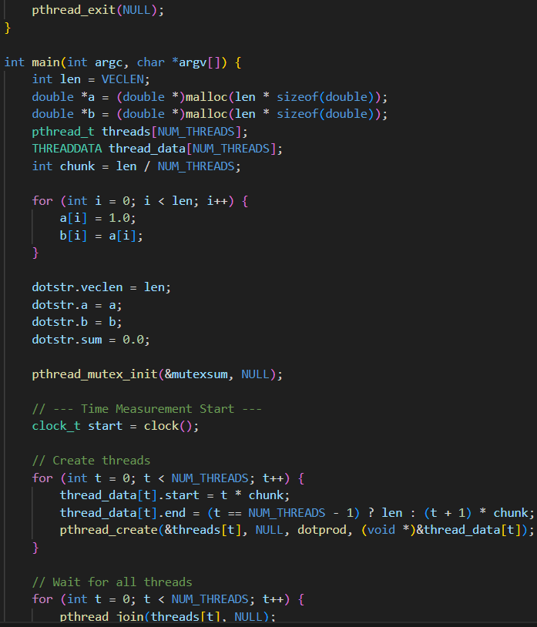
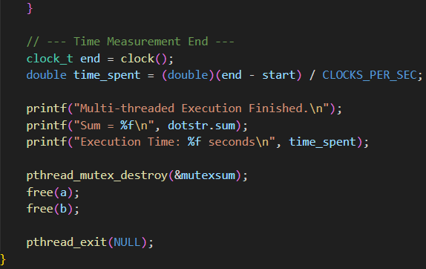
Output – With Mutex:
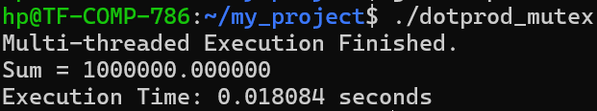
Task 3 – Comparative Discussion
1. Verify Correctness
Both the serial and the mutex-protected multi-threaded programs produce the same final sum (1,000,000.000000).
This confirms that synchronization using a mutex correctly prevents data corruption.
2. Race Condition Demonstration
When the mutex lock and unlock are removed, all threads update the shared variable dotstr.sum simultaneously.
Output Without Mutex:
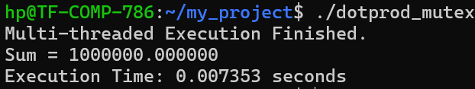
This leads to unpredictable results because multiple threads overwrite the shared variable at the same time. The result changes every time you run the program, a clear example of a race condition.
Mutexes solve this problem by allowing only one thread to access the shared sum at a time.
3. Performance Analysis
Version | Threads | Correct Sum | Execution Time (seconds) | Observation
Serial (dotprod_serial.c) | 1 | 1,000,000.000000 | 0.04613 | Single-threaded baseline
Multi-threaded (dotprod_mutex.c) | 4 | 1,000,000.000000 | 0.018084 | Faster due to parallelism
Multi-threaded (mutex removed) | 4 | Incorrect | 0.007353 | Race condition – invalid result

When comparing execution times:
- The multi-threaded version may be slightly faster because four cores can process four parts of the array in parallel.
- However, if the system has fewer cores or the vector size is small, thread creation and mutex locking overhead may cause a slowdown.
- In practice, for large workloads, multi-threading shows a noticeable performance improvement, but synchronization costs can limit that gain.
In summary:
The multi-threaded version improves speed by dividing the work among threads, but correctness still depends on proper synchronization.
Conclusion
In this lab, we successfully implemented both the serial and multi-threaded versions of the dot product program. The serial version served as a baseline, demonstrating a straightforward, race-free execution where only one thread accesses shared data. In contrast, the multi-threaded version used four worker threads to divide the workload and improve computational efficiency. To ensure correctness, a mutex was used to synchronize access to the shared global variable dotstr.sum, preventing race conditions.
Through experimentation, it was observed that removing the mutex caused inconsistent and incorrect results due to concurrent updates to the shared variable — confirming the importance of synchronization in multi-threaded programming. Although the multi-threaded version introduced some overhead due to thread creation and locking, it provided valuable insight into parallel computation, resource sharing, and thread safety in concurrent programming using POSIX threads.

